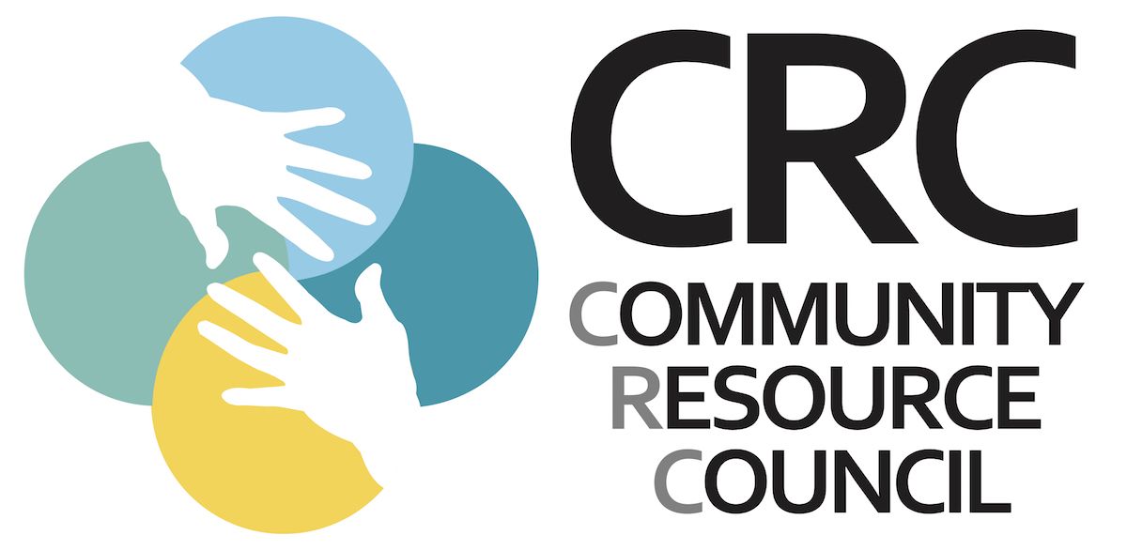
LOCAL RESOURCES FOR BOOTHBAY REGION

Food Resources
AOS 98: School Lunch
- Monday-Friday 11:30-12:30
- Curbside pickup
  - Boothbay Region Elementary School Main Entrance
  - Southport Central School Main Entrance
  - Edgecomb Eddy School Main Entrance
  - Boothbay Town Office parking lot- look for the bus
  - Boothbay Harbor YMCA parking lot- look for the bus

Boothbay Region Food Pantry:
Fleet Davies 350-2962
- Fridays 11:30-1:30
- Delivery available, call ahead
- Updates provided on Facebook page

Boothbay Region YMCA:
Andy Hamblett 633-2855
Student Weekend Lunch-Curbside Pickup
- 11:30-12:30, Saturday and Sunday

Food for Thought: Hannah Corkum 350-1743
(Healthy snack options for the weekend)
- In-home delivery every Fridays

Hannaford Supermarket (7am – 9 pm):
Manager-Nikki Emerson 633-6465
Senior Shopping Time: Tue-Thurs, 6-7am

Meals on Wheels: (elderly in-home meal delivery) Mary Lou Koskela 633-5761

Wiscasset Food Pantry: 882-9088

Other: See Boothbay Register https://www.boothbayregister.com/article/where-get-take-out-food-boothbay-region-and-what-closed/132153

Pharmacies:
Nathan’s Pharmacy: 315-2280
(Curbside pick up and home delivery)
Walgreens: 633-7023
(Delivery available)

Other Local Resources:
Boothbay Town Office: 633-2051
Boothbay Harbor Town Office: 633-3671
Boothbay Harbor Police Chief:
Robert Hasch 380-9903
Boothbay Harbor Fire Chief:
Nick Upham 380-5635
Boothbay Harbor Memorial Library:
Joanna Breen 633-3112 for (Unemployment Filing Assistance Only)
Boothbay Region Community Resource Council: 350-1743
-Hannah Corkum 350-1743 (client services)*
-Breanna Davis 633-4357 (volunteer coordinator-meal/grocery delivery)
-Holly Stover 350-7477

Health Care Facilities
Family Care Center-BBH: 633-7820
Lincoln Health-Damariscotta: 563-1234
Mid Coast Hospital: 373-6000
St. Andrews Urgent Care: 633-2121
The Boothbay Region Health Center: 633-1075 (M-F 8:30-4, Sat 10-4)

Mental Health
Addiction Outreach- BRCRC: 350-7477
Addiction Resource Center: 373-6950
Alanon-Statewide: 800-498-1844
Alcoholics Anonymous- 800-737-6237
Alliance on Mental Illness (NAMI): 800-464-5767
Boothbay Region Nursing & Outreach: 633-5533
Child Protective Services- DHHS: 800-452-1999
Healthy Lincoln County: 563-1330
Low Cost Drug Program: 855-797-4357
Maine Behavioral Health: 884-292-0111
Maine Domestic Violence Hotline: 866-834-4357
Mid Coast Hospital Outpatient Behavioral Health: 373-6980
New Hope for Women: 800-522-3304
Sexual Assault Support Services: 800-871-7741
Sweetser Behavioral Health: 800-434-3000 Veterans Medical Center- Togus: 877-421-8263

